\*Status of Kambuga Hospital and Services Offered\*

Kambuga Hospital is located in Kanungu District, Kinkiizi East. Established in 1965, it is owned by the Uganda Ministry of Health and administered by the Kanungu District Local Government.

On 29th March 2023, the groundbreaking ceremony for the refurbishment and upgrading of Kambuga Hospital into a referral hospital was conducted by Dr. Ruth Aceng, the Minister of Health. Dr. Aceng stated that Kambuga is a key priority in the government’s strategic plan for 2020-2025, with a budget of 43 billion UGX allocated in phases: 30 billion for construction and 13 billion for equipment. So far, 3 billion UGX has been utilized.

The ceremony was also attended by Dr. Chris Baryomunsi, Minister for ICT and National Guidance; Hon. Patience Nkunda, Woman MP of Kanungu District; the District Chairperson; the RDC; hospital staff; and community members.

\*Services Offered\*

Kambuga Hospital offers a wide range of services, including:

- Maternal and child health services

- Dental services

- Inpatient admission services

- X-ray and ultrasound services

- General outpatient services (OPD)

- General medical and surgical case management

- Orthopedic services

- Laboratory services

- HIV/TB services

- Community outreach services

- Health services

- Nutrition services

- Specialist surgical and gynecology services

- Mental health services

- Safe male circumcision

\*Key Personnel/ Contact persons

- \*\*Medical Superintendent:\*\* Dr. Kasudha Daniel (Contact: 0782374865)

- \*\*Senior Health Administrator (SHA):\*\* Mr. Twinamasiko Kenneth (Contact: 0774154327)

- \*\*Senior Nursing Officer:\*\* Mr. Mpimbazi Martin Mutabazi (Contact: 0782407851)

\*Location and Facilities\*

The hospital is situated in Ngarama Cell and Rugali, Central Ward, Kambuga Town Council.

In the 2023-2024 financial year, 3 billion UGX was received, and construction is being carried out by the UPDF Engineering Brigade.

As of 23rd July 2024, two main structures were being developed:

1. The upper unit, currently being roofed, consists of eight units (four on the lower level and four on the upper level).

2. The second structure, also at the roofing stage, comprises eight units (four on the lower level and four on the upper level).

In total, these staff quarters will provide 16 units, each with two bedrooms, a sitting room, a wardrobe, a bathroom, a toilet, a kitchen, and a battery room.

According to Dr. Kasudha Daniel, the ongoing construction is of high quality, but progress is slow.

Below are some pictorials for the works taking place at the hosipital

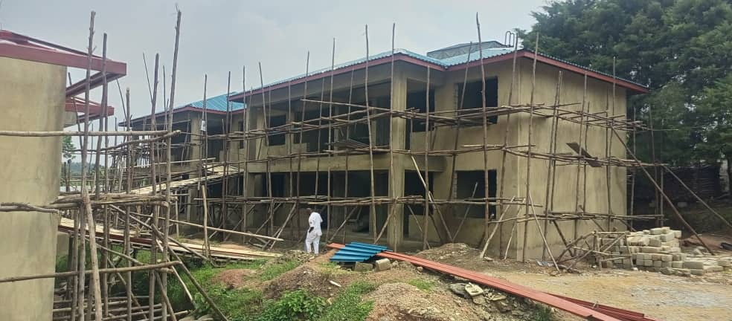

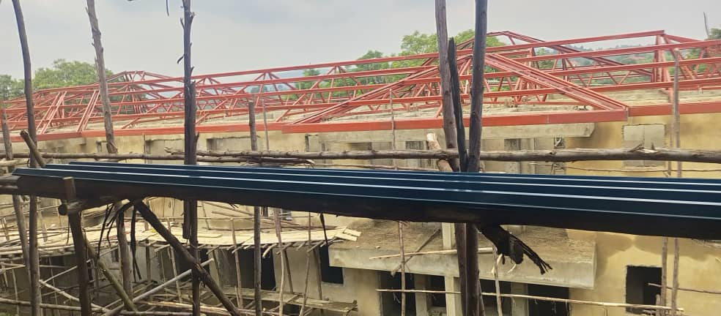

By: T. Mwajuma Twaha Adams

District Communications Officer, Kanungu District Local Government